Brooklyn torah gazette
For Parshas nitzavim - Vayeilech 5777
Volume 1, Issue 43 (Whole Number 43) 25 Elul 5777/ September 16, 2017
Printed L’illuy nishmas Nechama bas R’ Noach, a”h

For a free subscription, please forward your request to keren18@juno.com

In G-d We Trust



…You shall open your hand to your brother, to your poor, and to your destitute in your Land.” (15:11) S ign seen hanging in a store: “In G-d we trust, everyone else pays cash.”
A philosopher once asked Rabban Gamliel, “your Torah commands you over and over again to give charity, and to not be afraid of its affecting your financial security. Isn’t such a fear natural? How can a person give away his money without worrying that perhaps he should have saved it for a rainy day?” Rabban Gamliel asked him, “If someone asked you for a loan, would you agree?”
“Depends on who that someone is,” replied the philosopher. “If it’s someone I didn’t know, yes, I would be afraid of losing my money.”
“What if he had guarantors?” asked Rabban Gamliel. “Well, if I knew I could rely on them, I would agree.”
“How about if the guarantor was the Emperor, how would you feel about that?” “Well, of course, in those circumstances I would have total confidence that I’d get my money back.”
“When someone gives charity,” said Rabban Gamliel, “he’s actually extending a loan to the ‘Emperor of the Universe’. It says in the Book of Mishlei (Proverbs): One who gives graciously to the poor, extends, as it were, a loan to G-d, Who will pay back all that is due.”
G-d pays us back in this world by making sure we get back what we “loaned” Him. And, in the next world we get the full reward for our “loan”. no one is as trustworthy as G-d. If He guarantees to return our money, why should anyone have the slightest hesitation in giving charity?” • Source: based on the Midrash

Reprinted from the Parshat Re’eh 5777 email of OHRNET, the Ohr Somayach Torah Magazine of the Internet.

Find the Right Words
By Rabbi David Ashear

Words of Chizuk can make such an impact. They can do wonders for people, but it's hard to know the right words to say. Sometimes people are hurting so much, they don't want to hear anything. Sometimes we wish we could help, but we're afraid of saying the wrong thing. We must remember that we can always ask Hashem for help.
We can make a short prayer and say, "Please, Hashem, give me the right words to say to help this person cope with what he's going though."
A man told me that his close friend was in the hospital recently with his siblings saying their last good-byes to their father who had a terminal illness. They asked him to come, as he was also a physician and maybe could do something to help.
He got into the car having no idea what he could possibly do or say during this hard time. He knew the patient had stopped fighting to live and needed feeding tubes to stay alive.
He said, "When I arrived, I still didn't know what I was going to say. And then, Hashem put the words in my mouth. Words that were so uncharacteristic of me to say."
He said to the patient, "You have taught your children how to live and how to fear Hashem. You have accomplished so much in your life, but you are still their teacher. Now you have to teach them how to act when sick. You have so much strength; you have to show them the way Hashem expects us to be during these hard times, as well." He said some more words of Chizuk, and everybody there was inspired.
The family called him the next day, saying that their father's condition improved immensely. He looked healthier, he started eating and he even went out for a walk. Every moment of life counts. And the right words could add days and even years to a person's life.
Another man told me that when he was fifteen years old, he was in the hospital for an extended period. One day, three people from his community, who he didn't know that well, came into his room to visit him. They had just started a community Bikur Cholim and were excited to come and bring joy to those who were sick.
He and his mother said, "It's okay; we have everything we need. We're fine." But they insisted on coming in. They cheered him up and they left him a fake plant. He said that he became so inspired by their visit that he pledged to be like them when he got older.
And indeed, this man has spent his entire life involved in Chesed and community service. He eventually became president of the youth Bikur Cholim. He helped introduce the concept of a community Hatzala organization and was personally involved in developing it. He is still very active in Chesed, and he still has that plant in his house- forty years later. He said it's his inspiration; he looks at it and gets Chizuk from it, even today. It's amazing what one Bikur Cholim visit could accomplish.
I heard a rabbi giving a class, and he said that people sometimes give him feedback on the impact his classes have upon them. For example, there's a man from Los Angeles who had little interest in Judaism and was having a very hard time in business. It got to the point where he was suffering from depression.
One of his friends told him, "I know you don't listen to Torah classes, but please listen to this CD. I think it will help you."
The man said, "Okay, what do I have to lose? I'm driving somewhere now; I'll put it in my car." The trip was supposed to take him 25 minutes, but the man sat in his car for over two hours, listening to that rabbi's class. Afterwards, he was a changed man. His spirits were elevated, and he actually became religious from that one Shiur.
Words can do wonders; they are a gift from Hashem. Whenever we need the right words to say, we can ask Hashem to please give them to us.

Reprinted from the September 7, 2017 email of Emunah Daily.

The Red Carpet Treatment
By Rabbi Yaakov Asher Sinclair

“...that you should take of the first of every fruit of the ground that your bring in from your Land that the L-rd your G-d gives you, and you shall put it in a basket and go to the place that the L-rd your G-d will choose to make His Name rest there.” (Devorim 26:2)



I once heard Rabbi Noach Orlowek say to someone who had just complimented him on the shiur (lecture) he had given, “Thank you so much. Rabbis also need encouragement.”
If you were to ask me as a rebbe (teacher) in Ohr Somayach, what is the most important quality that a rebbe must have, I would say the ability to give one’s talmidim (students) the belief that they can succeed.
The Mishna in Tractate Bikurim says that when the bearers of the “first fruits” approached Jerusalem, even hired workers in the middle of their work were obliged to down tools and greet them, saying: “Welcome, our brothers from (such and such place)!” and a flute played in front of them all the way until they reached the Temple Mount with their offerings.
The Talmud (Kiddushin 33a and Chullin 54b) points out an apparent contradiction to this. it says that a hired worker is forbidden to stop his work even to stand for a Talmid Chacham (Torah scholar). Rabbi Yosi bar Avin resolves this matter:
“In the case of bikurim, if the bringers don’t receive an enthusiastic reception there is a possibility that next year they won’t want to go through the trouble of bringing their first fruits up to Jerusalem at all.”
There is something puzzling about this: The halacha says that a hired worker is forbidden to stop work even to greet a Torah scholar — in other words that’s the right thing to do.
Nevertheless when it comes to bikurim, if the workers don’t stop and greet those bringing their bikurim they are considered in the wrong. But surely, those who are bringing the bikurim should overcome their feelings of lethargy and rouse themselves even though they will not get a “red-carpet” reception!
After all, it’s their mitzvah. even if a talmid lacks the appropriate motivation to fulfill his mitzvah of learning Torah, but the rebbe has not done everything to roll out the red carpet for him — to imbue him with the enthusiasm and the belief that he can succeed — the responsibility is the rebbe’s and not the talmid’s.
My father was a furniture manufacturer for most of his adult life. He used to say to me, “There’s no such thing as a bad worker — just a bad boss.” If that’s true of furniture, how much more are we, as teachers and mentors, responsible for the success of our wards? • Source: based on the Chiddushei Halev

Reprinted from the Parshat Ki Savo 5777 email of OHRNET, the Ohr Somayach Torah Magazine of the Internet.

His Bravery Unsung, Varian Fry Acted to Save Jews
By Gina Bellafante

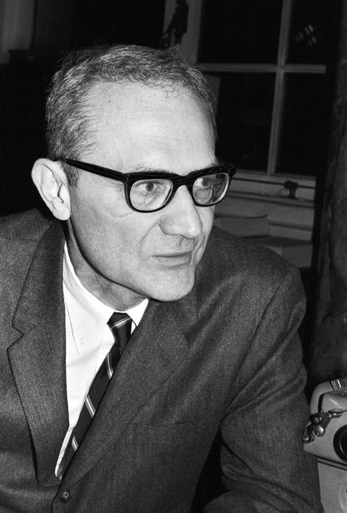
The American journalist Varian Fry in 1967. He helped artists like Marc Chagall and Marcel Duchamp escape the Nazis during World War IICreditFred Stein/DPA, via Associated Press

In June of 1935, two years after the German government falsely portrayed the burning of the Reichstag as a Communist plot to overthrow the state and just at the moment that it had banned all but “Aryans’’ from serving in the military and made homosexuality a crime, Varian Fry, a young Manhattan editor who was preparing to take over a magazine called The Living Age, traveled to Berlin.
About one month into his stay, he witnessed a night of gruesome rioting in which Jews were kicked, bloodied and spat on, leaving him to provide one of the earliest accounts of Nazi cruelties in the American news media. Relaying his observations to The Associated Press, Fry remarked that the police “nowhere’’ seemed “to make any effort whatever to save victims from this brutality.’’ Occasionally, he said, “they attempted to clear areas for motor traffic,’’ or to keep people from congregating in front of beloved cafes, but “that was all.’’ The crowds — made up of people young and old, well-bred-looking and common — chanting “‘The best Jew is a dead Jew,’” he continued, conducted themselves as if “in holiday mood.’’
The impression left was so searing that journalism alone became insufficient. During times of crisis, ordinary people often ask themselves what they can do; Fry’s pursuit of this line of self-inquiry did not take him to a place of protest clothes and phone banking.
He became a founding member of the Emergency Rescue Committee, a group of activists who opposed the restrictive Immigration Act of 1924, sentiments of which are echoed in the Trump plan to stop protections against the deportation of young immigrants, worrying that the quotas it imposed would prevent refugees in need from finding safety in this country. The committee was concerned in particular about foreigners who had fled to southern France — an unoccupied part of the country under Vichy control — and who could now be turned over to the Nazis at any time.
With that in mind, in August 1940, Fry, a Protestant and 32-year-old, went to Marseilles to begin a covert rescue operation that during his 13-month stay would result in the escape of more than 2,000 people, among them many artists and intellectuals, including Marc Chagall, Hannah Arendt, Max Ernst, Heinrich Mann, Marcel Duchamp, André Breton, Jacques Lipchitz and Alma Mahler, who crossed the Pyrenees carrying Gustav Mahler’s Symphony No. 10, her former husband’s final composition.
Given the scope of his heroism and its implications for the momentum of 20th century cultural life, Fry remains relatively little known. He died in 1967, in Connecticut, a high school Latin teacher. In an announcement of his engagement to a Democratic Party political operative named Annette Riley in The New York Times in 1950, Fry is identified as the president of a film company called Cinemart, Inc. with no mention of his work during the war.
Fry is buried in Green-Wood Cemetery, in Brooklyn, where he had spent summers as a young boy with a grandfather who was active in the Children’s Aid Society. Earlier this year officials at Green-Wood got a call from someone prominent in immigration circles who suggested that Fry receive some considered attention. The moment seemed to demand it. As a result Fry’s life and legacy is the subject of a symposium scheduled at the cemetery for this weekend with panelists from the worlds of art and humanitarian aid.
While Fry was exceptional in some ways — an impressive student who graduated from Harvard having created an influential literary magazine with his friend Lincoln Kirstein, a co-founder of the New York City Ballet — there was little about him that would have presaged his outsize acts of bravery. “He was not James Bond,’’ Jeff Richman, Green-Wood’s resident historian said. Rejecting a name that seemed to destine him for espionage, Fry as a child at school asked to be called Tommy.
In June 1940, he had sent a letter to Eleanor Roosevelt explaining that there was an urgent need for someone — “an adventurous daredevil’’ — to go to France and risk his life in an attempt to “save the intended victims of Hitler’s chopping block.” But Fry did not see himself in the role, in part because his own command of French and German was merely “halting,’’ he wrote and because he had “no experience whatever in detective work.”
He hoped that either Mrs. Roosevelt or her husband could suggest someone, but when no such individual surfaced, he volunteered as if there were no other reasonable choice — strapping $3,000 to his leg as he left New York, holding meetings in bathrooms with the water running to evade the detection of German spies who had planted listening devices. Moral calling inserted him in a world of black market money, forged passports and visas and clandestine mountain routes. He stayed in France, having originally imagined it would only be for a few weeks, long past the point at which he understood it was dangerous.
When Fry returned to the United States, parties were not thrown. The State Department, which had insisted on keeping the number of immigrants bound for the United States low, hardly approved of what he had been doing. Fry’s one ally was the vice counsel in Marseilles, Hiram Bingham IV, who helped provide Fry’s passengers with travel documents, some of them fraudulent, after a few hundred authorized emergency visas had run out.
Bingham suffered too for his rectitude, never advancing significantly in the Foreign Service. Instead he retired in his 40s to a farm in Connecticut to paint and play the cello. Today both men would find much more to do.

Reprinted from the September 7, 2017 website of The New York Times. A version of this article appeared in print on September 10, 2017, on Page MB1 of the New York edition with the headline: A True Hero,

Burial
By Rabbi Yirmiyahu Ullman

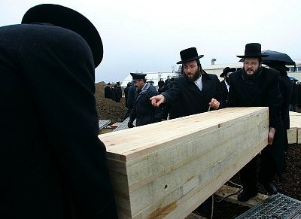

From: Shirley in Denver

Dear Rabbi, The Torah says that man must return to dust. Does this necessarily mean burial, or could cremation also be acceptable?

Dear Shirley, your question involves two issues, burial and cremation. This week I’ll discuss burial, and another time — G-d willing —cremation. The requirement to bury the dead is from the verse, “if a man committed a sin worthy of death you shall surely bury him that day” (Deut. 21:23).
The verse “For you are dust and to dust you shall return” (Gen. 3:19) teaches that ideally a buried body should be in contact with the ground. Upon death the soul cannot fully depart until the body has completely disintegrated. on the other hand, an abrupt departure would cause the soul great agony.
Burial ensures the gradual, but eventual, decay of the body, needed to benefit the soul. Our sages thus remarked: burial is not for the sake of the living, but rather for the dead. Burial actually preceded the giving of the Torah.
The Midrash relates that G-d brought before Cain a bird burying another, in order to teach him to bury Hevel. similarly, all of the Patriarchs and Matriarchs were buried: “and his sons buried [Abraham]” (Gen. 25:9-10); “and [Isaac’s] sons buried him” (Gen. 35:29); “for his sons buried [Jacob]” (50:13); “Abraham buried Sarah” (Gen. 23:19); “there they buried Rebecca and Leah” (Gen. 49:31); and “[Jacob] buried [Rachel] in Beit Lechem” (Gen. 48:7).

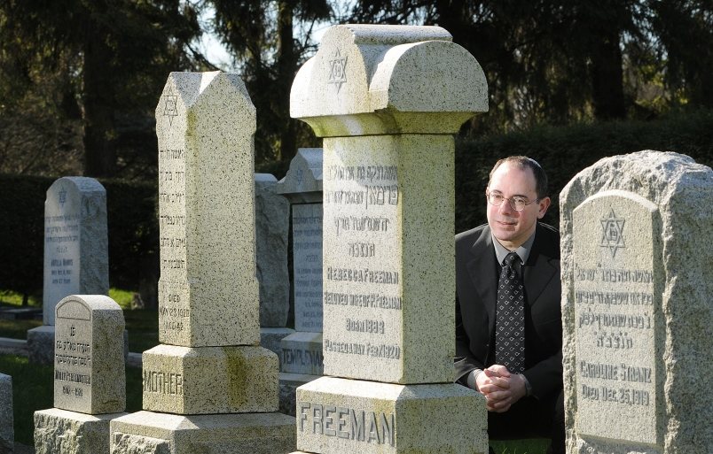

Even Joseph, who died in Egypt, imposed an oath on the children of Israel saying, “G-d will surely visit you, and you shall carry up my bones from here” (Gen. 50:25). Moses fulfilled the oath (ex. 13:19) and eventually the bones of Joseph they buried in Shechem (Joshua 24:32).
Further, the Talmud teaches that one of the ways a Jew imitates G-d in performing acts of righteousness is by burying the dead, as G-d did for Moses: “and He buried him in the valley in the land of Moav” (Deut. 34:6).
After the giving of the Torah burial became obligatory. Counted as one of the 613 commandments of the Torah, anyone who prevents himself or others from being buried uproots a positive Torah requirement to bury, and also transgresses a negative Torah prohibition of leaving a body unburied. In fact, the Talmud states that anyone who orders before his death that his body should not be buried, his order must be disregarded — and this is the halacha.
Sources: • R. Manashe ben Israel, Nishmat Chaim 2:26 • Sanhedrin 47a • Tur, Yoreh De’ah 362; Beit Yosef in the name of Ramban, Torat HaAdam p. 117 • Tanchuma, Ber. 10. See also Ber. Rabba 22:8 and Pirkei d’Rabbi Eliezer 21 • Sotah 14a • Rambam, Sanhedrin 15:8; Evel 12:1; Sefer HaMitzvot, aseh 231 • Halachot Gedolot; Semag 104; Sefer HaChinuch 537 • Sanhedrin 46b; Rambam, Evel 12.1; Shulchan Aruch, Yoreh De’ah 348:2
Reprinted from the Parshas Ki Savo 5777 email of OHRNET, The Ohr Somayach Torah Magazine of the Internet.
Living with The Times

The Importance of the
Unity of the Jewish People
Adapted from the works of
Rabbi Menachem M. Schneerson, zt”l
The Lubavitcher Rebbe.
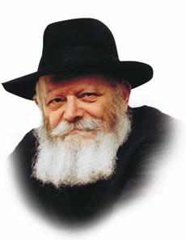

The Torah portion of Nitzavim is always read the Shabbat before Rosh Hashana. "You are standing today, all of you, before the L-rd your G-d," it begins, and the theme of Jewish unity, as preparation for the New Year continues.
"Today" refers to Rosh Hashana, and "standing" refers to the way the Jewish People approach the Day of Judgement, upright and secure that we will be judged favorably, for we stand as one and are unified in the mitzva of loving our fellow Jew.
It is this special unity which gives the Jewish people the strength to endure, and it is the vessel in which G-d's blessings are fulfilled. The Midrash likens this to a bundle of straw: each one, individually, is weak and can be easily broken, but once the straw is gathered into a bundle and bound together it is impossible to make it bend.
So it is with the Jewish people. When we are bound together with each other, "the leaders of your tribes...till your water carriers," we stand powerful and secure in the face of our enemies.
The Jews are also powerfully united with G-d, as it says, "a portion of G-d is with him." But if such is the case, how is it possible for any bad to befall the Jews? This only occurs if the individual Jew himself causes a tiny rift in that bond with G-d and allows external factors to enter. It is this self-induced damage in the relationship between G-d and His people which brings about a lack of unity and makes the Jews vulnerable to harm. When peace and unity reign the Jews are impervious to attack.
Maintaining this unity also guards against these tiny cracks appearing in the individual's relationship with G-d. A person is not always able to perceive his own shortcomings because of his self-love. A true friend, however, can lovingly help his friend become aware of these shortcomings and encourage him to overcome his deficiencies.
This is one of the reasons Rabbi Dov Ber of Lubavitch encouraged his followers to acquire a friend for this specific purpose--to encourage and inspire each other. He explained that when two Jews unite to improve themselves and their relationship with G-d, their two G-dly souls are fighting only one Evil Inclination, and it is far easier to emerge victorious.
If this was true several generations ago during the lifetime of Rabbi Dov Ber, it is so much more applicable in our own times, when we have fallen that much lower spiritually. How much more important it is for us to maintain that unity, for we need all the help we can get to fight the negative influences in the modern world.
Unfortunately, tiny cracks in the Jews' bond with their Father ar more likely to appear during times of relative affluence. The threat of persecution was not as harmful to our Jewishness as are the temptations of affluence and comfort. It is much easier to deteriorate spiritually in a prosperous climate than when the outside world threatens our very physical existence.
We must therefore not only maintain our adherence to the Torah but we must also strive to perform mitzvot with a special love and devotion. Doing mitzvot in this manner gives us the strength and determination to guard against anything which threatens our eternal bond with G-d, both from within and from without.

Reprinted from the Parshat Nitzavim 5752/1992 edition of L’Chaim Weekly, a publication of the Lubavitch Youth Organization in Brooklyn, NY.

Rabbi Berel Wein on
Parshat Nitzavim - Vayelech 5777

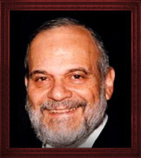

Ah! The covenant once more. The basis of the relationship between the Jewish people and their Creator is the covenant that exists between them. The covenant is central to the story of the Jewish people. Our father Avraham entered into and created the terms of this eternal covenant. The covenant was embodied in his flesh itself and sanctified by the sense of sacrifice that the historical narrative of Avraham and Yitzchak reinforced.
Yaakov received the covenant from his father – after contests with Eisav and Lavan and bequeathed it to his sons, the twelve tribes of Israel. His family took the covenant with them down to Egypt and it was miraculously preserved throughout centuries of slavery. Yosef had promised them redemption and belief in the existence and efficacy of the covenant. And that promise of redemption for all ages and future conditions was attached to the overriding theme of the covenant.
To this historical and faith narrative was added the holy spirituality and Divine laws of the Torah granted at Mount Sinai. This combination of holiness, the discipline of behavior, the historical narrative of tradition and family, all combined to form the foundation of the covenant.
This has remained the great backbone of Jewish survival during our long and painful exile and dispersion. It is this covenant that unites Jews the world over as a family, not only as a faith and not only as a nationality.
The continuity and presence of this covenant – alive and well as it assuredly is in our time now – was and is the leitmotif of the rhythms of Jewish life everywhere. The covenant was binding upon all Jews even though many Jews, especially in modern times, were completely unaware of its existence and the grip it exerted on their lives and society.
It is this covenant that governs Jewish history and our current events as well. There is no other rational way to look at our story, past, present and undoubtedly future, in the absence of the overriding influence and presence of the covenant that Moshe and Israel entered into as recorded in this week’s Torah reading.
The demands of the covenant are strong and oftentimes appear to be severe. But an “easy” covenant would be useless considering the challenges and rigors of Jewish history. Rabbi Moshe Feinstein often stated: “People say it is difficult to be a Jew and they are correct in that assessment. But I say that it is even more difficult for a Jew not to be a Jew!”
Such is the nature of G-d’s covenant with us and it has proven to be eternal and binding for all of the millennia of Jewish existence. That is why this is the final major public act of the career of Moshe as the leader of the Jewish people. As long as the covenant holds, he is assured of the eternity of Israel and his own immortality.

Reprinted from the Parshat Nitzavim-Vayelech 5777 website of RabbiWein.com

Outreach by Default
By Rabbi Eli J. Mansour

Moshe Rabbenu tells us in Parashat Nisavim (29:28), “Ha’nistarot L’Hashem Elokenu Ve’ha’niglot Lanu U’l’banenu Ad Olam” – “That which is hidden belongs to Hashem our G-d; but that which is revealed is for us and our children, forever.”
This verse establishes the concept of collective responsibility toward Torah observance. We committed ourselves to the Torah together as a nation, and not just as individuals. And therefore, we have a responsibility to see to it, as best we can, that all other Jews observe the Misvot.
It does not suffice to ensure that we and our families are devoted to the Torah. We must also be concerned that all our fellow Jews are likewise committed. This verse tells us that although we are not responsible for the “Nistarot,” for the sins we are not aware of, the “Niglot”– the spiritual ills and failings of which we are aware –are our responsibility to address.

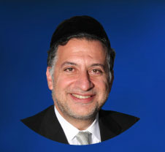
Rabbi Eli J. Mansour

The Hafetz Haim (Rav Yisrael Meir Kagan of Radin, 1839-1933) explained this concept through an analogy to a borrower who borrowed a large sum of money and asked a friend to sign as his guarantor. Sometime later, the guarantor sees his friend, the borrower, walking into a casino with a wallet stuffed with money. The guarantor rushes up to him and reprimands him for going gambling.
“What’s it to you?” the friend angrily retorts. “It’s my money, so I can do what I want with it.”
“Oh no,” the guarantor replies. “This directly affects me. If you throw your money away, I’m the one who’s going to have to come up with a million dollars to repay your loan!”
Similarly, the Hafetz Haim explains, it is very much our business whether our fellow Jews observe the Torah, because we accepted collective responsibility toward it. We all jointly share the consequences of the nation’s collective success or, Heaven forbid, failure to observe the Misvot, and we must therefore do what we can to bring back those who have strayed from observance.
Of course, this responsibility gives rise to the question of how this can be done. People don’t like being told what to do. It’s clear and obvious to everyone that if we go up to non-observant Jews and angrily reprimand them for violating the Torah, this tactic will not succeed. If anything, it will breed resentment that will further distance these precious Jews from our heritage.
The solution is to affect people without saying a word, to show them the beauty of Misvot and the satisfaction they bring without talking about it. When we see, for example, a great Torah Sage poring over his Torah books with passion and excitement, we are inspired. And even the rest of us can inspire people by performing Misvot with fervor and enthusiasm.
If people see us feeling happy and fulfilled for having chosen a Torah lifestyle, they might be open to the idea of trying it out. If we have non-observant guests for Shabbat meal and they see and feel the special joy of a family sitting together, sharing ideas and singing Pizmonim, this will have an effect.
But if people see us performing Misvot begrudgingly, complaining about the responsibilities and rushing through them as fast as we can, they will remain distant from Torah life, and will in fact be happy that they do not embrace our lifestyle.
We do not have to – and we should not – go over to our fellow Jews and tell them directly they must be observing the Torah. But what we can and must do is reach out to them automatically, by default, exuding joy and fulfillment in our performance of Misvot, and making it clear that we view Torah life as a great privilege and source of unparalleled satisfaction.

Reprinted from this week’s website of the Edmund J. Safra Synagogue of Brooklyn.

Rav Avigdor Miller on
The Lesson of Hurricanes

QUESTION: What could we learn from the hurricane that was supposed to come today? {this question was referencing either Hurricane Gordon or Hurricane Helene of late September 2000}

ANSWER: The hurricane first of all is a test. will you come hear the lecture? They say a hurricane might be coming, and everyone is all nervous and excited, and despite that, you came. You get more reward for that. according to the effort required, so too will be the reward.
Secondly, from the hurricane we learn - "Hashem, put Your fear on the world" (Rosh Hashana Amidah). Hashem does it to make fear. You have to be afraid of Hashem. A hurricane - Chas V’shalom - much worse could have happened. It turned out it didn't happen, it's nice and quiet, boruch Hashem. But the fear of the hurricane is enough. The fear of the hurricane is enough to make you a changed man - if you're wise enough to use the opportunity.

You know, I always say, there's a din in the Torah of the Ben Sorer UMorer , a son who is disobedient, and he steals from his parents' money, and he buys meat and wine. So his parents can accuse him before beis din, and they whip him, they give him malkus (lashes). And if he does it a second time, his parents bring him before beis din and they kill him. A little young boy of twelve-years-old. And everybody pelts him with stones. All the people of the town come and they throw stones at him and kill him.

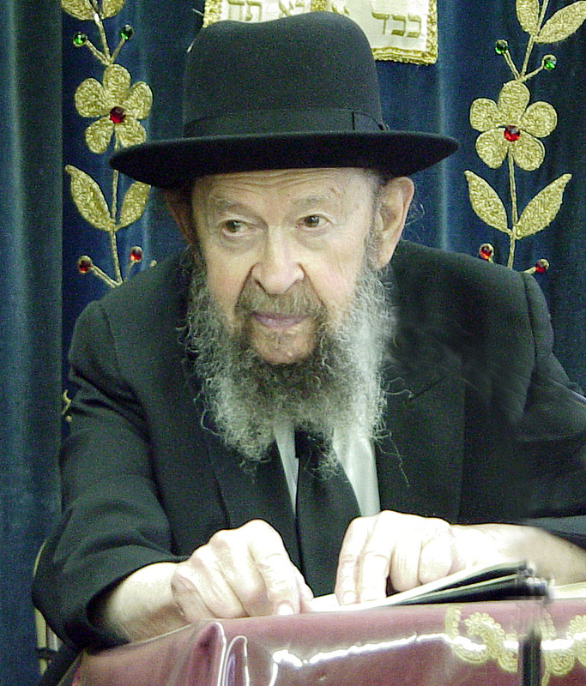
Rabbi Avigdor Miller
Now this scenario has so many conditions in the Gemaras. There are so many conditions that must be fulfilled in order to kill him, that some say that it never happened. It's so hard to fulfill because there are so many conditions attached, so it never even happened. But if it never could happen, why is written in the Torah?
The answer is that all the little boys who learn Chumash, all the little boys in Cheder, are frightened to death by it. They learn the Chumash with their Rebbi, and they're frightened. Oh, it's wonderful. That lesson is wonderful. To be afraid of being wicked. "If I'm wicked, this could happen to me," the little boy is thinking. He doesn't know the lomdus in Mesichta Sanhedrin, all the conditions and difficulties, the chumrahs, stringencies that make it impossible. He doesn't know about that. To be afraid is a tremendous thing. Learn to be afraid of Hashem!
And that's why, when we study the principles of the Torah, even if it's things that won't happen in our days, nevertheless the fact that it did happen once, is a tremendous opportunity.
Reprinted from the September 11, 2017 email of Toras Avigdor. Email: info@torasavigdor.org

